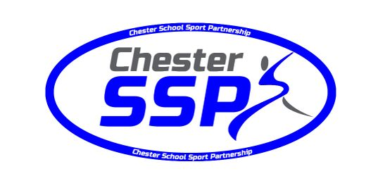

Chester School Sport Partnership
Sports Awards 2017-2018.

Recognising and celebrating pupil achievement in
Physical Education and School Sport

This is our second Awards evening and is the ideal opportunity to give pupils and schools the recognition they deserve for their hard work, commitment and passion for Physical Education and School Sport in the Chester School Sport Partnership area.

Awards categories are:
Young Male Sports Performer of the Year (Primary)
Young Female Sports Performer of the Year (Primary)
Young Male Sports Performer of the Year (Secondary)
Young Female Sports Performer of the Year (Secondary)
Primary Sports Team of the Year
Secondary Sports Team of the Year
Special School Team / Club of the Year
Club Aimed to Increase Physical Activity in the Least Active
The Special Recognition Award

Schools can make no more than 2 nominations per category.
The closing date for nominations is Friday 22nd June 2018. All entries must be sent to Chester School Sport Partnership Sports Awards, Blacon High School, Melbourne Road, Blacon, Chester, CH1 5JH. Or by email to enewstead@blaconhigh.cheshire.sch.uk / claire.smedley@blaconhigh.cheshire.sch.uk
Entries received after this closing date will not be considered.
Invitations for the evening will be sent to all relevant nominations after the shortlisting for each category.
Attendance on the evening will be strictly invitation only.

Chester School Sport Partnership
Sports Awards Nomination Form 2017-2018.

Name of person / team / club being nominated:

School name:

Year:

Name of teacher nominating:

Contact email address of the person making the nomination:

Award category (please tick one from the list):

Young Male Sports Performer of the Year (Primary) – Nominations are sought from primary schools for their young performer who has made the most significant contribution to PE and sport in their school / community and / or who has competed at the highest level.
Young Female Sports Performer of the Year (Primary) – Nominations are sought from primary schools for their young performer who has made the most significant contribution to PE and sport in their school / community and / or who has competed at the highest level.
Young /Male Sports Performer of the Year (Secondary) – Nominations are sought from secondary schools for their young performer who has made the most significant contribution to PE and sport in their school / community and / or who has competed at the highest level.
Young Female Sports Performer of the Year (Secondary) – Nominations are sought from secondary schools for their young performer who has made the most significant contribution to PE and sport in their school / community and / or who has competed at the highest level.
Primary Sports Team of the Year – Nominations are sought from primary schools for a school team that has excelled this year / had successes / shared outstanding team work (School Games Values).
Secondary Sports Team of the Year - Nominations are sought from secondary schools for a school team that has excelled this year / had successes / shared outstanding team work (School Games Values).
Special School Team / Club of the Year – Nominations are sought from special schools for a team / club that has made the most significant contribution to PE and sport in their school / community, or has excelled in their sport.
Club Aimed to Increase Physical Activity in the Least Active – Nominations are sought from schools for a Club that has made the most significant contribution to increasing physical activity and participation, PE and sport in their school / community.
The Special Recognition Award – Nominations are sought from schools to nominate someone who has shown a long standing contribution to school sport and / or for working above and beyond their role within school sport.
Please describe and evidence, in up to 500 words, why you think he / she / they deserve this recognition and award (please do not submit the same text for multiple nominations).

Please return all nomination forms, a photograph and / or a short video of the person / team being nominated by Friday 22nd June 2018 to Chester School Sport Partnership Sports Awards, Blacon High School, Melbourne Road, Blacon, Chester, CH1 5JH.
Or by email to enewstead@blaconhigh.cheshire.sch.uk / claire.smedley@blaconhigh.cheshire.sch.uk
Entries received after this date will not be considered.
Please note that by submitting photographs /video content with this nomination form, the person making the nomination has consent from the parents / guardians of the person / people in the photograph / video. Images may be used in the SSP Newsletter, and on the evening itself.

